Mobile E-Commerce

A Skill Oriented Course Web Application report

Submitted in the partial fulfillment of the requirements for

the award of the degree of

Bachelor of Technology

In

Computer Science and Engineering

by

Student Name: MOHAMMAD BASITH ANWAR KHAN

Roll Number: 20761A05A2

Under the guidance of

Dr. K Devi Priya
Associate Professor, Dept. of CSE


Department of Computer Science and Engineering
Lakireddy Bali Reddy College of Engineering (Autonomous)
Accredited by NAAC & NBA (Under Tier - I)
Affiliated to JNTUK, Kakinada; ISO 9001:2015 Certified
2021-22

Certificate

This is to certify that the Skill Oriented Course Web Application / Project entitled
“Mobile E-Commerce” is being submitted by MOHAMMAD BASITH ANWAR KHAN in partial fulfillment for the award of B. Tech in Computer Science & Engineering to the Jawaharlal Nehru Technological University Kakinada is a record of bonafide work carried out by him/her under our guidance.

The results embodied in this Skill Oriented Course Web Application / Project report have not been submitted to any other University or Institute for the award of any degree or diploma.

Projectguide Head of the department
Dr. K Devi Priya, Dr.D.Veeraiah,
Associate Professor. Professor.

External Examiner
ACKNOWLEDGEMENT

I would like to thank Dr. K Devi Priya, Associate Professor, CSE department for the encouraging and support in carrying out this Skill Oriented Course Web Application.

I also take the privilege to record my thanks to Dr. D. Veeraiah, Professor,Head of the Department of CSE whose encouragement, cooperation and valuable support crown my success.

I express my thanks to the support given by management in completing my Web Application / Project. I also express my sincere gratitude & deep sense of respect to the Principal, Dr.K. Appa Rao for making us available all the required assistance and his support and inspiration to carry out this Skill Oriented Course Web Application / Project in the Institute.

I am thankful to the teaching and non-teaching staff of CSE department for their direct as well as indirect help in my Skill Oriented Course Web Application / Project.

I am elated to avail my selves to this opportunity to express my deep sense of gratitude to my parents.
CONTENTS
CONCEPTS Page No
1.Abstract 3
2.Introduction 4
3. Technologies Used
3.1 HTML (HYPER TEXT MARKUP LANGUAGE) 5-12
3.2 CSS (CASCADING STYLE SHEETS) 12-18
3.3 JS (JAVA SCRIPT) 18-26
4. Project Codes
4.1 Home page code 27-31 4.2 Login page code 32-37
4.3 Main page code 38-41
5. Result Screens
5.1 Home page 42
5.2 Collection page 43
5.3 Mobile Page 44
5.4 Contact page 45
5.5 About Page 46
6. Implementation 47
7. Conclusion 48
8. Reference 49

Mobile E-Commerce

Abstract
Mobile Commerce is an evolving area of e-Commerce, where users can interact with the service providers through a mobile and wireless network, using mobile devices for information retrieval and transaction processing.
M-Commerce services and applications can be adopted through different wireless and mobile networks, with the aid of several mobile devices. However, constraints of both mobile networks and devices influence their operational performance; therefore, there is a strong need for taking into consideration those constraints in the design and development phases of m-Commerce services and applications. Another important factor in designing m-Commerce services and applications is the identification of mobile users requirements.
Furthermore, m-Commerce services and applications need to be classified based on the functionality they provide to the mobile users. This kind of classification results in two major classes: the directory and the transaction-oriented services and applications. This paper suggests a new approach for designing and developing m-Commerce services and applications.
This approach relies on mobile users needs and requirements, the classification of the m-Commerce services and applications, as well as the current technologies for mobile and wireless computing and their constraints.

INTRODUCTION :

Mobile and e-commerce applications are tools for accessing the Internet and for buying products and services. These applications are constantly evolving due to the high rate of technological advances being made. This paper provides a new perspective on the types of applications that can be used.
It describes and analyses device requirements, provides a literature review of important aspects of mobile devices that can use such applications and the requirements of websites designed for m-commerce. The design and security aspects of mobile devices are also investigated.
As an alternative to existing m-commerce applications, this paper also investigates the characteristics and potential of the PhoneGap cross-mobile platform application. The results suggest that effective mobile applications do exist for various Smartphones, and web applications on mobile devices should be effective.
PhoneGap and Spree applications can communicate using JSON instead of the XML language. Android simulators can be used for ensuring proper functionality and for compiling the applications.

TECHNOLOGIES USED:

1.HTML : (HYPER TEXT MARKUP LANGUAGE)
- HTML stands for Hyper Text Markup Language
- HTML is the standard markup language for creating Web pages
- HTML describes the structure of a Web page
- HTML consists of a series of elements
- HTML elements tell the browser how to display the content
- HTML elements label pieces of content such as "this is a heading", "this is a paragraph", "this is a link", etc.

BASIC TAGS :
- The <!DOCTYPE html> declaration defines that this document is an HTML5 document
- The <html> element is the root element of an HTML page
- The <head> element contains meta information about the HTML page
- The <title> element specifies a title for the HTML page (which is shown in the browser's title bar or in the page's tab)
- The <body> element defines the document's body, and is a container for all the visible contents, such as headings, paragraphs, images, hyperlinks, tables, lists, etc.
- The <h1> element defines a large heading
- The <p> element defines a paragraph

SOME BASIC CONCEPTS OF HTML:

1.HTML Links - Hyperlinks
- HTML links are hyperlinks.
- You can click on a link and jump to another document.
- When you move the mouse over a link, the mouse arrow will turn into a little hand.
- A link does not have to be text. A link can be an image or any other HTML element
Syntax:
The HTML <a> tag defines a hyperlink. It has the following syntax:
<a href="url">link text</a>
The most important attribute of the <a> element is the href attribute, which indicates the link's destination.
The link text is the part that will be visible to the reader.
Clicking on the link text, will send the reader to the specified URL address.
By default, links will appear as follows in all browsers:
- An unvisited link is underlined and blue
- A visited link is underlined and purple
- An active link is underlined and red
By default, the linked page will be displayed in the current browser window. To change this, you must specify another target for the link.
The target attribute specifies where to open the linked document.
The target attribute can have one of the following values:
- _self - Default. Opens the document in the same window/tab as it was clicked
- _blank - Opens the document in a new window or tab
- _parent - Opens the document in the parent frame
- _top - Opens the document in the full body of the window
2.INSERTING IMAGES:
Images can improve the design and the appearance of a web page.
- The HTML <img> tag is used to embed an image in a web page.
- Images are not technically inserted into a web page; images are linked to web pages. The <img> tag creates a holding space for the referenced image.
- The <img> tag is empty, it contains attributes only, and does not have a closing tag.
The <img> tag has two required attributes:
- src - Specifies the path to the image
- alt - Specifies an alternate text for the image
Syntax:
<img src="url" alt="alternatetext">

3.HTML TABLES:
- HTML tables allow web developers to arrange data into rows and columns.
- A table in HTML consists of table cells inside rows and column.
- Each table cell is defined by a <td> and a </td> tag.
- td stands for table data.
- Everything between <td> and </td> are the content of the table cell.
- Each table row starts with a <tr> and end with a </tr> tag.
- tr stands for table row.
- Sometimes you want your cells to be headers, in those cases use the <th> tag instead of the <td> tag
Syntax:
<table>
<tr>
<th>column 1</th>
<th>column 2</th>
<th>column 3</th>
</tr>
<tr>
<td>data item 1</td>
<td>data item 2</td>
<td>data item 3</td>
</tr>
</table>

4.HTML LISTS:

  - HTML lists allow web developers to group a set of related items in lists.
  - An unordered list starts with the <ul> tag. Each list item starts with the <li> tag.
    - The list items will be marked with bullets (small black circles) by default.
  - An ordered list starts with the <ol> tag. Each list item starts with the <li> tag.
    - The list items will be marked with numbers by default.

Syntax and example:

- Unordered list

<ul>
<li>Coffee</li>
<li>Tea</li>
<li>Milk</li>
</ul>

Output:
- Coffee
- Tea
- Milk
- Ordered list
<ol>
<li>Coffee</li>
<li>Tea</li>
<li>Milk</li>
</ol>

Output:

- Coffee
- Tea
- Milk

5.HTML FORMS:
- An HTML form is used to collect user input. The user input is most often sent to a server for processing.
- The HTML <form> element is used to create an HTML form for user input.
- The <form> element is a container for different types of input elements, such as: text fields, checkboxes, radio buttons, submit buttons, etc.

Syntax:
<form>
.
form elements
.
</form>
Elements:

1.input: The HTML <input> element is the most used form element.
An <input> element can be displayed in many ways, depending on the type attribute.
- <input type="button">
- <input type="checkbox">
- <input type="email">
- <input type="password">
- <input type="submit">
- <input type="text">

2.label:
The <label> tag defines a label for many form elements.
The <label> element is useful for screen-reader users, because the screen-reader will read out loud the label when the user focus on the input element.
The for attribute of the <label> tag should be equal to the id attribute of the <input> element to bind them together.
Syntax: <label for=”name”>labelname</label>

Example:
<form>
<label for="fname">First name:</label><br>
<input type="text" id="fname" name="fname"><br>
<label for="lname">Last name:</label><br>
<input type="text" id="lname" name="lname">
</form>
Output:
First name:
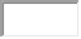
Last name:
2.CSS : (CASCADING STYLE SHEETS)

- CSS stands for Cascading Style Sheets
- CSS describes how HTML elements are to be displayed on screen, paper, or in other media
- CSS saves a lot of work. It can control the layout of multiple web pages all at once
- External stylesheets are stored in CSS files.
WHY WE HAVE TO USE CSS:
  - HTML was NEVER intended to contain tags for formatting a web page!
  - HTML was created to describe the content of a web page, like:
  - <h1>This is a heading</h1> And <p>This is a paragraph.</p>
  - When tags like <font>, and color attributes were added to the HTML 3.2 specification, it started a nightmare for web developers. Development of large websites, where fonts and color information were added to every single page, became a long and expensive process.
  - To solve this problem, the World Wide Web Consortium (W3C) created CSS.
  - CSS removed the style formatting from the HTML page!
SYNTAX:
A CSS rule consists of a selector and a declaration block.
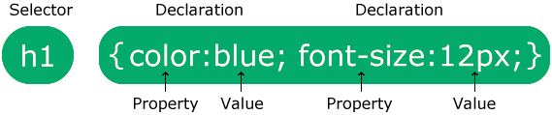
- The selector points to the HTML element you want to style.
- The declaration block contains one or more declarations separated by semicolons.
- Each declaration includes a CSS property name and a value, separated by a colon.
- Multiple CSS declarations are separated with semicolons, and declaration blocks are surrounded by curly braces.
EXAMPLE:
p {
color: red;
text-align: center;
}

CSS SELECTORS:
CSS selectors are used to "find" (or select) the HTML elements you want to style.
We can divide CSS selectors into five categories:
- Simple selectors (select elements based on name, id, class)
- Combinator selectors (select elements based on a specific relationship between them)
- Pseudo-class selectors (select elements based on a certain state)
- Pseudo-elements selectors (select and style a part of an element)
- Attribute selectors (select elements based on an attribute or attribute value)
ELEMENT SELECTOR:
p {
text-align: center;
color: red;
}

ID SELECTOR:
#para1 {
text-align: center;
color: red;
}

CLASS SELECTOR:
.center {
text-align: center;
color: red;
}

UNIVERSAL SELECTOR:
* {
text-align: center;
color: blue;
}

ADDING CSS TO HTML DOCUMENT

There are three ways of inserting a style sheet:
- External CSS
- Internal CSS
- Inline CSS

1.EXTERNAL CSS
With an external style sheet, you can change the look of an entire website by changing just one file!
Each HTML page must include a reference to the external style sheet file inside the <link> element, inside the head section.
Example:
<!DOCTYPE html>
<html>
<head>
<link rel="stylesheet" href="mystyle.css">
</head>
<body>
<h1>This is a heading</h1>
<p>This is a paragraph.</p>
</body>
</html>
An external style sheet can be written in any text editor, and must be saved with a .css extension.
The external .css file should not contain any HTML tags.

2.INTERNAL CSS:
An external style sheet can be written in any text editor, and must be saved with a .css extension.
The external .css file should not contain any HTML tags.

Example:
<!DOCTYPE html>
<html>
<head>
<style>
body {
background-color: linen;
}
h1 {
color: maroon;
margin-left: 40px;
}
</style>
</head>
<body>
<h1>This is a heading</h1>
<p>This is a paragraph.</p>
</body>
</html>

3.INLINE CSS:
An inline style may be used to apply a unique style for a single element.
To use inline styles, add the style attribute to the relevant element. The style attribute can contain any CSS property.
Example:
<!DOCTYPE html>
<html>
<body>
<h1 style="color:blue;text-align:center;">This is a heading</h1>
<p style="color:red;">This is a paragraph.</p>
</body>
</html>

CASCADING ORDER:
What style will be used when there is more than one style specified for an HTML element?
All the styles in a page will "cascade" into a new "virtual" style sheet by the following rules, where number one has the highest priority:
- Inline style (inside an HTML element)
- External and internal style sheets (in the head section)
- Browser default
So, an inline style has the highest priority, and will override external and internal styles and browser defaults.

3.JS : (JAVA SCRIPT)

- JavaScript is the world's most popular programming language.
- JavaScript is the programming language of the Web.
- JavaScript is easy to learn.
- JavaScript is one of the 3 languages all web developers must learn:
1. HTML to define the content of web pages
2. CSS to specify the layout of web pages
3. JavaScript to program the behavior of web pages
HOW TO ADD JS FILE TO HTML:
In HTML, JavaScript code is inserted between <script> and </script> tags.
Example:
<script>
document.getElementById("demo").innerHTML = "My First JavaScript";
</script>
You can place any number of scripts in an HTML document.
Scripts can be placed in the <body>, or in the <head> section of an HTML page, or in both.
FUNCTIONS AND EVENTS:
A JavaScript function is a block of JavaScript code, that can be executed when "called" for.
For example, a function can be called when an event occurs, like when the user clicks a button.
Example:
<!DOCTYPE html>
<html>
<head>
<script>
function myFunction() {
document.getElementById("demo").innerHTML = "Paragraph changed.";
}
</script>
</head>
<body>
<h2>Demo JavaScript in Head</h2>
<p id="demo">A Paragraph</p>
<button type="button" onclick="myFunction()">Try it</button>
</body>
</html>

JAVA SCRIPT OUTPUT:
JavaScript can "display" data in different ways:
- Writing into an HTML element, using innerHTML.
- Writing into the HTML output using document.write().
- Writing into an alert box, using window.alert().
- Writing into the browser console, using console.log().
To access an HTML element, JavaScript can use the document.getElementById(id) method.
The id attribute defines the HTML element. The innerHTML property defines the HTML content.
Example:
<!DOCTYPE html>
<html>
<body>
<h1>My First Web Page</h1>
<p>My First Paragraph</p>
<p id="demo"></p>
<script>
document.getElementById("demo").innerHTML = 5 + 6;
</script>
</body>
</html>

Output:

My First Web Page
My First Paragraph.
11

JAVA SCRIPT SYNTAXES:
JavaScript syntax is the set of rules, how JavaScript programs are constructed:
// How to create variables:
var x;
let y;
// How to use variables:
x = 5;
y = 6;
let z = x + y;

VARIABLES AND LITERALS:
The JavaScript syntax defines two types of values:
- Fixed values
- Variable values
Fixed values are called Literals.
- Numbers are written with or without decimals:
10.50
1001
- Strings are text, written within double or single quotes:
  - "John Doe"
'John Doe'

Variable values are called Variables.
- In a programming language, variables are used to store data values.
- JavaScript uses the keywords var, let and const to declare variables.
- An equal sign is used to assign values to variables.
- In this example, x is defined as a variable. Then, x is assigned (given) the value 6:
let x;
x=6;

JAVA SCRIPT FUNCTIONS:
A JavaScript function is defined with the function keyword, followed by a name, followed by parentheses ().
Function names can contain letters, digits, underscores, and dollar signs (same rules as variables).
The parentheses may include parameter names separated by commas:
(parameter1, parameter2, ...)
The code to be executed, by the function, is placed inside curly brackets: {}
SYNTAX:
function name(parameter1, parameter2, parameter3) {
// code to be executed
}
- Function parameters are listed inside the parentheses () in the function definition.
- Function arguments are the values received by the function when it is invoked.
- Inside the function, the arguments (the parameters) behave as local variables.
FUNCTION INVOCATION:
The code inside the function will execute when "something" invokes (calls) the function:
- When an event occurs (when a user clicks a button)
- When it is invoked (called) from JavaScript code
- Automatically (self invoked)
FUNCTION RETURN:
When JavaScript reaches a return statement, the function will stop executing.
If the function was invoked from a statement, JavaScript will "return" to execute the code after the invoking statement.
Functions often compute a return value. The return value is "returned" back to the "caller".
Example:
let x = myFunction(4, 3);
// Function is called, return value will end up in x
function myFunction(a, b) {
return a * b; // Function returns the product of a and b
}
OUTPUT:
The result in x will be:
12

ADVANTAGES:
You can reuse code: Define the code once, and use it many times.
You can use the same code many times with different arguments, to produce different results.

REGULAR EXPRESSIONS (REGEX);

A regular expression is a sequence of characters that forms a search pattern.
When you search for data in a text, you can use this search pattern to describe what you are searching for.
A regular expression can be a single character, or a more complicated pattern.
Regular expressions can be used to perform all types of text search and text replace operations.

SYNTAX:
/pattern/modifiers;

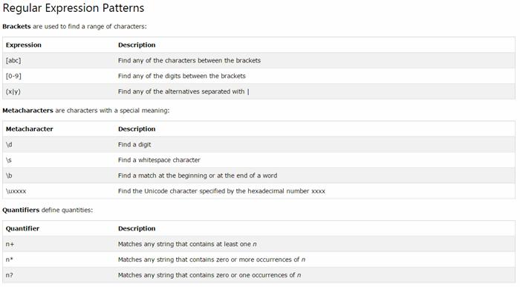

PROJECT CODE:

HOME PAGE CODE:

HTML FILE:

<!DOCTYPE html>
<html lang="en">
<head>
<meta charset="UTF-8" />
<meta name="viewport" content="width=device-width, initial-scale=1.0" />
<link
href="https://fonts.googleapis.com/css?family=Roboto&display=swap"
rel="stylesheet"
/>
<link
rel="stylesheet"
href="https://cdnjs.cloudflare.com/ajax/libs/font-awesome/5.13.0/css/all.min.css"
/>
<link rel="stylesheet" href="home.css" />
<title>Fashion</title>
</head>
<body>
<header>
<nav>
<div class="logo">
<h1>ANWAR KHAN</h1>
</div>
<ul class="list-items">
<li><a href="home.html" class="link">HOME</a></li>
<li><a href="col.html" class="link">COLLECTION</a></li>
<li><a href="contact.html" class="link">CONTACT US</a></li>
<li><a href="about.html" class="link">ABOUT US</a></li>
</ul>

<div class="nav-btns">
<a href="#" class="btn-nav-i"><i class="fas fa-cart-plus"></i></a>
<a href="#" class="btn-nav-i"><i class="fas fa-search"></i></a>
</div>
</nav>
<div class="main">
<div class="main-left">
<div class="social-media">
<a href="#" class="s-btn"><i class="fab fa-facebook-f"></i></a>
<a href="#" class="s-btn"><i class="fab fa-twitter"></i></a>
<a href="#" class="s-btn"><i class="fab fa-instagram"></i></a>
</div>
<div class="banner">
<div class="f-text">
<h1>
TECHNOLOGY
<br />
<span>MADE</span>
<br />
SIMPLE
</h1>
</div>
<a href="col.html" class="btn">EXPLORE NOW</a>
</div>
</div>
<div class="main-right">
<img src="iphone.jpg" />
</div>
</div>
</header>
</body>
</html>

CSS FILE:

* {
padding: 0;
margin: 0;
box-sizing: border-box;
}

body {
font-family: sans-serif;
}

header {
width: 100%;
height: 100vh;
}

nav {
background: black;
display: flex;
width: 100%;
height: 10vh;
align-items: center;
}

.logo {
width: 20%;
padding-left: 50px;
color: white;
}

.list-items {
display: flex;
list-style: none;
width: 50%;
justify-content: space-around;
}

.link {
text-decoration: none;
font-weight: bold;
color: white;
font-size: 13px;
transition: 0.4s;
}

.link1 {
text-decoration: none;
font-weight: bold;
color: rgb(12, 11, 11);
font-size: 13px;
transition: 0.4s;
}

.link:hover {
color: #db5dab;
}

.nav-btns {
width: 30%;
font-size: 20px;
}

.btn-nav-i {
color: white;
float: right;
padding-right: 20px;
transition: 0.4s;
}

.btn-nav-i:hover {
color: #db5dab;
}

.main {
background: black;
position: relative;
height: 90vh;
width: 100%;
}
.main-left {
position: absolute;
top: 0;
height: 100%;
width: 65%;
}
.main-right {
position: absolute;
top: 0;
right: 0;
height: 100%;
width: 35%;
background: black;
}

.main-right img {
height: 100%;
width: 100%;
object-fit: contain;
animation: animation 5s forwards;
animation-delay: 1s;
opacity: 0;
}

@keyframes animation {
0% {
opacity: 0;
}

100% {
opacity: 1;
}
}

.social-media {
position: absolute;
height: 100%;
width: 70px;
display: flex;
flex-direction: column;
align-items: center;
justify-content: center;
}

.social-media::before {
content: "";
position: absolute;
width: 2px;
height: 30%;
background: white;
top: 20px;
}
.social-media::after {
content: "";
position: absolute;
width: 2px;
height: 30%;
background: white;
bottom: 20px;
}

.s-btn {
color: rgb(236, 95, 177);
margin-top: 20px;
transition: 0.4s;
font-size: 20px;
}

.s-btn:hover {
color: #db5dab;
}

.banner {
height: 100%;
width: 100%;
display: flex;
flex-direction: column;
align-items: center;
justify-content: center;
}

.f-text h1 {
text-align: center;
font-size: 4rem;
letter-spacing: 0.5rem;
color: white;
}

.f-text span {
color: #db5dab;
}

.btn {
margin-top: 20px;
text-decoration: none;
color: rgb(252, 53, 169);
border: solid 1px white;
padding: 20px 40px;
transition: 0.4s;
}

.btn:hover {
background: #db5dab;
}

COLLECTION PAGE CODE:

HTML FILE:

<!DOCTYPE html>
<html lang="en">
<head>
<meta charset="UTF-8" />
<meta name="viewport" content="width=device-width, initial-scale=1.0" />
<link
href="https://fonts.googleapis.com/css?family=Roboto&display=swap"
rel="stylesheet"
/>
<link
rel="stylesheet"
href="https://cdnjs.cloudflare.com/ajax/libs/font-awesome/5.13.0/css/all.min.css"
/>
<link rel="stylesheet" href="home.css" />
<title>COLLECTION</title>
</head>
<body>
<header>
<nav>
<div class="logo">
<h1>COLLECTIONS</h1>
</div>
<ul class="list-items">
<li><a href="home.html" class="link">HOME</a></li>
<li><a href="col.html" class="link">COLLECTION</a></li>
<li><a href="contact.html" class="link">CONTACT US</a></li>
<li><a href="about.html" class="link">ABOUT US</a></li>
</ul>

<div class="nav-btns">
<a href="#" class="btn-nav-i"><i class="fas fa-cart-plus"></i></a>
<a href="#" class="btn-nav-i"><i class="fas fa-search"></i></a>
</div>
</nav>
<div class="main">

<div class="banner">
<div class="f-text">

</div>
<a href="mob1.html" class="btn">Apple</a>
<a href="mob2.html" class="btn">Samsung</a>
<a href="mob3.html" class="btn">Nokia </a>
<a href="mob4.html" class="btn">One Plus</a>
<a href="mod5.html" class="btn">Huawei</a>
</div>
</div>

</div>

</header>
</body>
</html>

MOBILE PAGE CODE:

HTML CODE:

<!DOCTYPE html>
<html>
<head>

<title>Page Title</title>

<link rel='stylesheet' type='text/css' media='screen' href='profilec.css'>
<script src="https://kit.fontawesome.com/b99e675b6e.js"></script>

</head>
<body>

<div class="wrapper">
<div class="left">
<img src="iphone1.jpg" alt="user" width="100">
<h4>Iphone</h4>
<p>13 Pro Max</p>
</div>
<div class="right">
<div class="info">
<h3>Information</h3>
<div class="info_data">
<div class="data">
<h4>Brand</h4>
<p>Apple</p>
</div>
<div class="data">
<h4>Model</h4>
<p>iPhone 13 Series</p>
</div>
</div>
</div>

<div class="projects">
<h3>Specification</h3>
<div class="projects_data">
<div class="data">
<h4>Availabilty</h4>
<p>Available Currently</p>
</div>
<div class="data">
<h4>Price</h4>
<p>$699</p>
</div>
</div>
</div>

<div class="social_media">
<ul>
<li><a href="home.html"><i>Home</i></a></li>
<li><a href="https://www.amazon.in/s?k=iphone13&crid=1K81NKGJ5HQNM&sprefix=iphone13%2Caps%2C471&ref=nb_sb_noss_1"><i>Shop</i></a></li>
<li><a href="mob2.html"><i class="fas fa-forward"></i></a></li>
</ul>
</div>
</div>
</div>
</body>
</html>

HOMEPAGE:



COLLECTIONS PAGE:
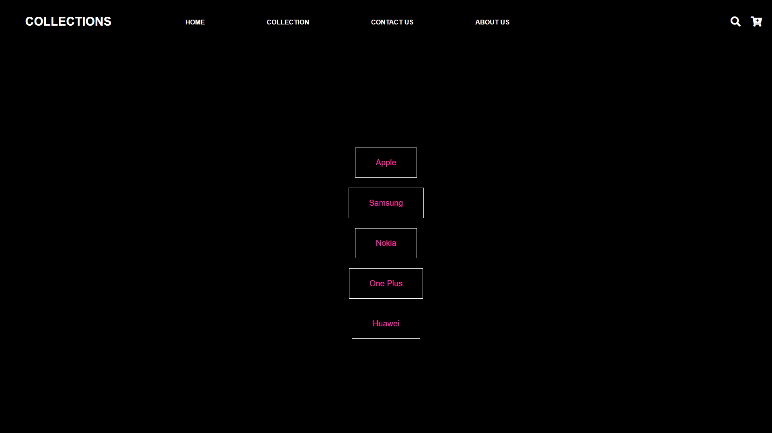
MOBILE PAGE:
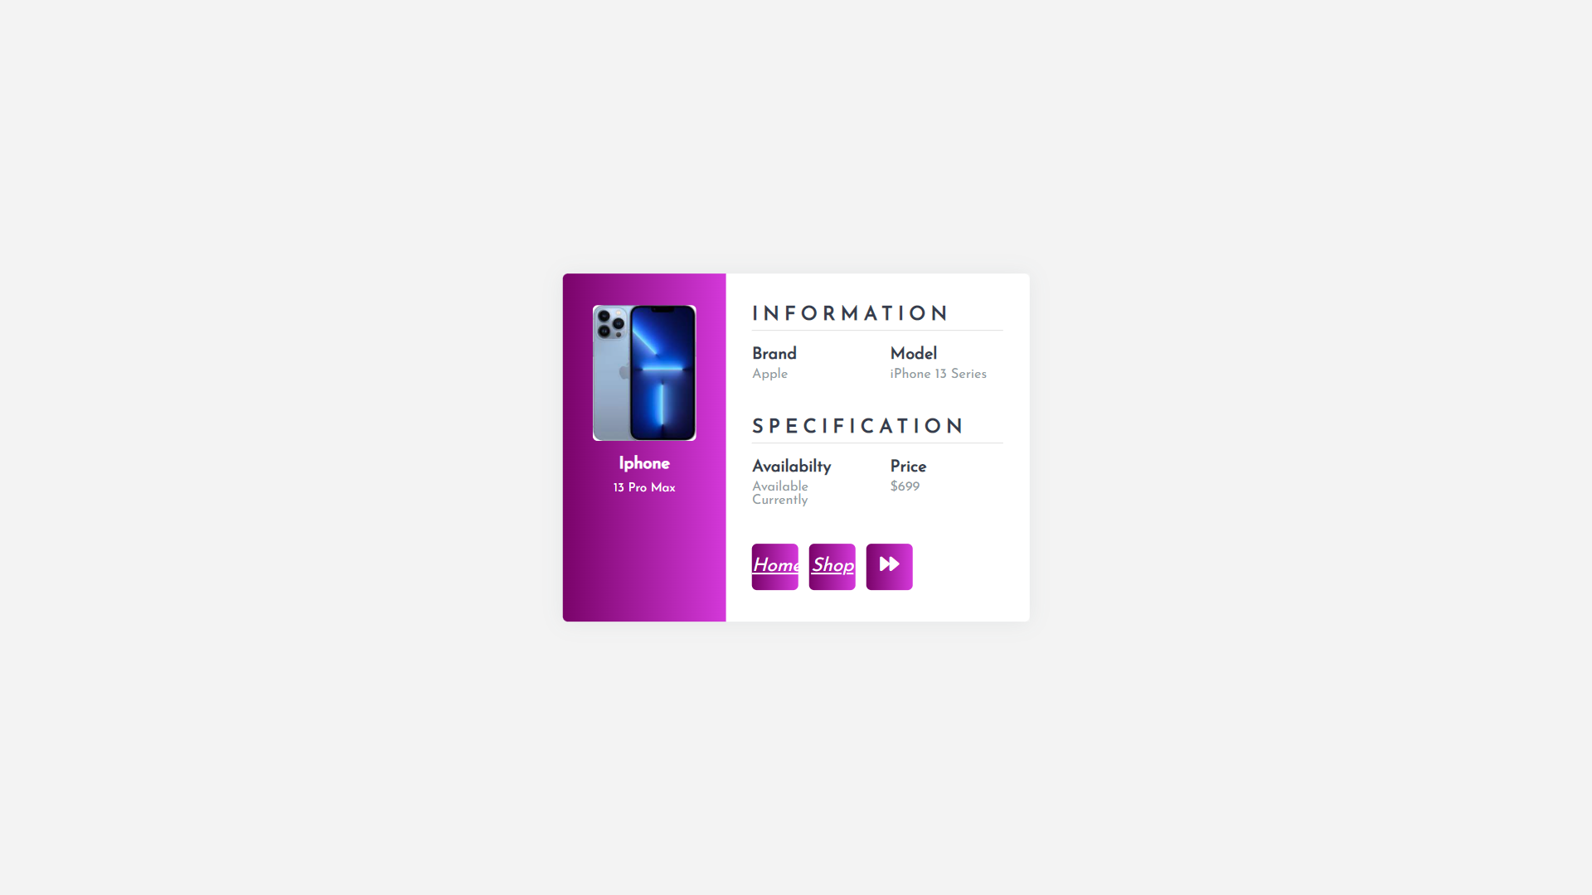
CONTACT PAGE:

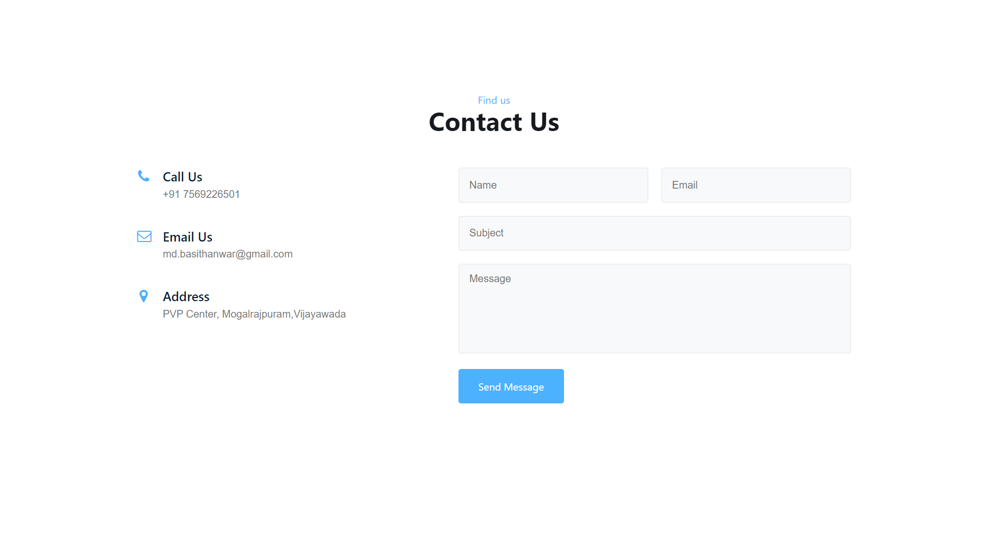

ABOUT PAGE:

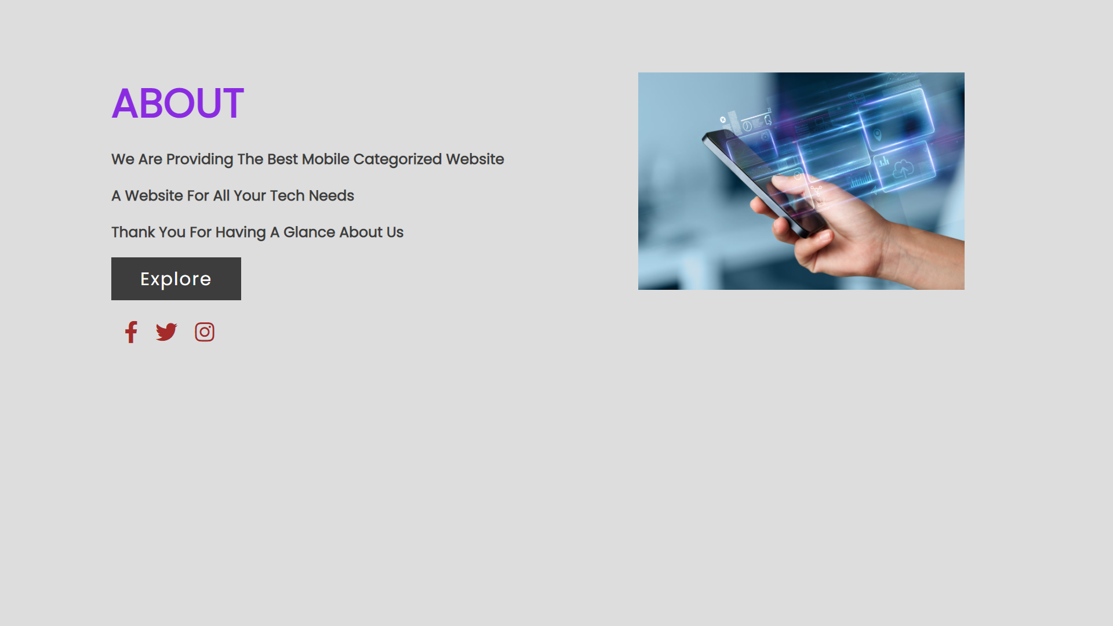

PAGE - IMPLEMENTATION:

This web application is user friendly to use and work. It contains a welcome which user can allow to login by using email and password. If the user does not have an account then user can redirected to register page. After entering the details user can use the application by gathering the information of the particular mobile phone. There are many utilities in this application that the user can shop his favourite phone.

If user find any difficulties he can directly give the feedback by going to the feedback page with his email and mobile number and he can directly contact to developer by the information provided in the contact page. If any queries related to this webpage the user has full access and support from the developer.

CONCLUSION:

The main aim of this web application is to provide user a facilitate environment to access mobile phone information from the e-commerce website for what he/she can want in their personal choice for booking our favourite mobile phone. The Phone shopped by the user can access the information by them only. No other person can allowed to access because the login information provided by the user can only know.

REFERENCE:

The webpage was developed by using so many networking sites and informative tutorial pages.
Some of them were listed below.

  - W3 SCHOOLS : https://www.w3schools.com/html/default.asp
  - CODINGNEPAL: https://www.codingnepalweb.com/category/html-and-css/
  - CODEPEN:
https://codepen.io/pen/tour/welcome/start

